- Outline
  - The concept of covenant
    - What is a covenant?
    - What covenant did God make?
    - How is the covenant explained in the Bible?
  - The atonement – the core of the covenant
Gen 3:15
Rev. 14:6
Nahum 1:9
Rev. 21:1-4

  - The atonement in today’s lesson
    - Sunday – Gen. 3:15
    - Monday – Abraham’s sacrifice
    - Tuesday – Golden calf experience
    - Wednesday – Isaiah 53
    - Thursday – Daniel and the time frame
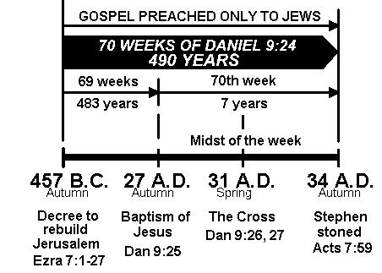

- Two Seventh-day Adventist Fundamental
Beliefs About “Covenant”
9. Life, Death, and Resurrection of Christ:
In Christ's life of perfect obedience to God's will, His suffering, death, and resurrection, God provided the only means of atonement for human sin, so that those who by faith accept this atonement may have eternal life, and the whole creation may better understand the infinite and holy love of the Creator. This perfect atonement vindicates the righteousness of God's law and the graciousness of His character; for it both condemns our sin and provides for our forgiveness. The death of Christ is substitutionary and expiatory, reconciling and transforming. The resurrection of Christ proclaims God's triumph over the forces of evil, and for those who accept the atonement assures their final victory over sin and death. It declares the Lordship of Jesus Christ, before whom every knee in heaven and on earth will bow. (John 3:16; Isa. 53; 1 Peter 2:21, 22; 1 Cor. 15:3, 4, 20-22; 2 Cor. 5:14, 15, 19-21; Rom. 1:4; 3:25; 4:25; 8:3, 4; 1 John 2:2; 4:10; Col. 2:15; Phil. 2:6-11.)
19. Law of God:
The great principles of God's law are embodied in the Ten Commandments and exemplified in the life of Christ. They express God's love, will, and purposes concerning human conduct and relationships and are binding upon all people in every age. These precepts are the basis of God's covenant with His people and the standard in God's judgment. Through the agency of the Holy Spirit they point out sin and awaken a sense of need for a Saviour. Salvation is all of grace and not of works, but its fruitage is obedience to the Commandments. This obedience develops Christian character and results in a sense of well-being. It is an evidence of our love for the Lord and our concern for our fellow men. The obedience of faith demonstrates the power of Christ to transform lives, and therefore strengthens Christian witness. (Ex. 20:1-17; Ps. 40:7, 8; Matt. 22:36-40; Deut. 28:1-14; Matt. 5:17-20; Heb. 8:8-10; John 15:7-10; Eph. 2:8-10; 1 John 5:3; Rom. 8:3, 4; Ps. 19:7-14.)
- What Most Protestant Churches Believe About the Covenant

Old Covenant (Testament)
= salvation by works
New Covenant (Testament) = salvation by grace

- What Seventh-day Adventist Believe About the Covenant

Rev 14:6 - “Everlasting covenant. . .” – The great controversy theme

Gen 3:15
Nahum 1:9
Salvation is always by grace, but that does not suspend or supersede the continuing existence of God’s law and its stipulations
“Old” covenant =Literal Israel tried to live either outside the law (apostasy) or “through the law” = Pharisaism
“New” covenant =Spiritual Israel responds through faith to the grace of God.

- The covenant is not “old” or “new” in terms of time, but in terms of how people relate and respond to it.
- I have a question about this week’s lesson!

- The most important thing I learned this week is:

- I got the most spiritual help this week from this thought:

- I learned something new this week. . .:

